

Advanced Database Concepts

Final Project

Presented by

Hector Gonzalez Barron

**Table of Contents**

**Problem Background** **3**

**Existing Solutions** **3**

**Project** **4**

**Database Design** **5**

**Entities** **6**

**Bibliography** **7**

# Problem Background

Serve as a platform to analyze collections of data relating to service and manufacturing industries where human interaction is significantly present. Based on the nature of this work, there's a larger variation that is observed and special causes should be analyzed.

# Existing Solutions

***Promodel*** 1can simulate Industrial (Machine), and Service (Healthcare, Services, Pharmaceutical) processes. Based on statistics or forecasted individual activity times, it builds a simulation of scenarios with machines, people, and machine-people.

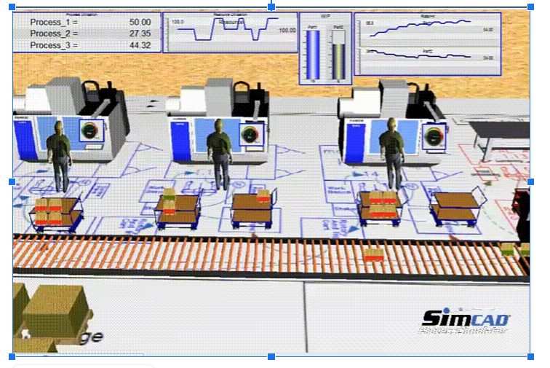

***Standard Time***2 describes itself as a timesheet and time-tracking solution for project management in industries where human labor is intensive. The software is designed to capture data around manufacturing time-tracking, shop floor management, and work-in-process, as well as other data.

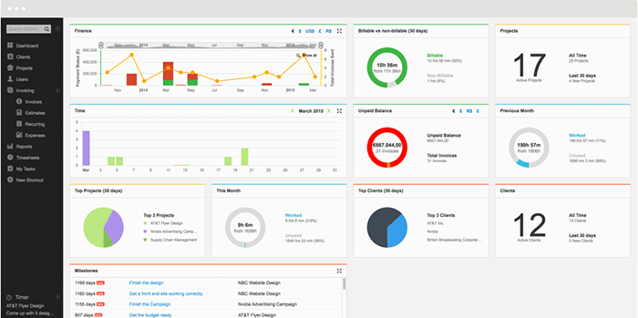

# **Project**

This database will provide a necessary yet currently missing link between the simulation of a process and the data captured from the actual, real-time implementation of that process.

Raw data must be processed if companies are to derive insights that are material to them in being able to drive decision-making and innovation. The project I propose offers a solution to companies for processing this unprocessed data, bringing them to a point where it can drive further action items. Control Charts3 ( x̅ - s charts, specifically) will be used to monitor the process. Following, a test (in the form of eight rules) will be performed to analyze these charts (see Table 1). Due to the time constraint this project will be focused on Rule 1, which is the first step in the process control analysis.

The database will acquire the raw data and perform the calculations needed to obtain the range, known as control limits; the average (x̅), the standard deviation (s), and the limits are obtained by x̅ +/- 3s. Failure to Rule 1 (value out of range) will create a record on a log table with pertinent information.

Since this solution will provide information to make decisions, reliability becomes a key, therefore relational database is the selected option.

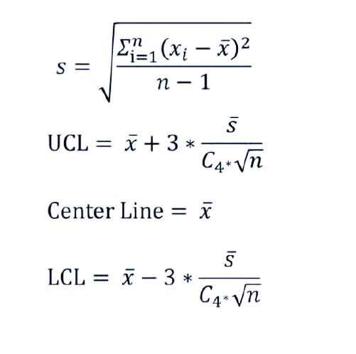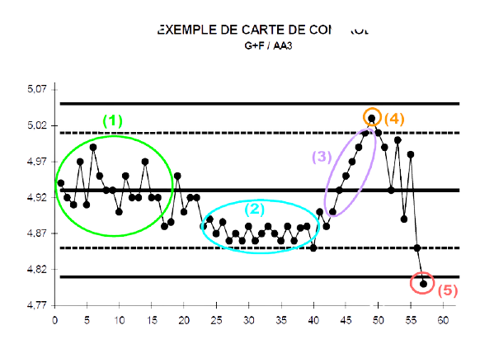

The three, out of eight, principal rules are validated

1. Values beyond Control Limits
2. Trends (upwards & downwards)
3. Stratification

* Common Table Expression w/wo recursion
* Temporary tables
* Row_Number()
* Math Calculations
* Stored procedures
* Common calculations stored in independent procedures

# **Database Design**

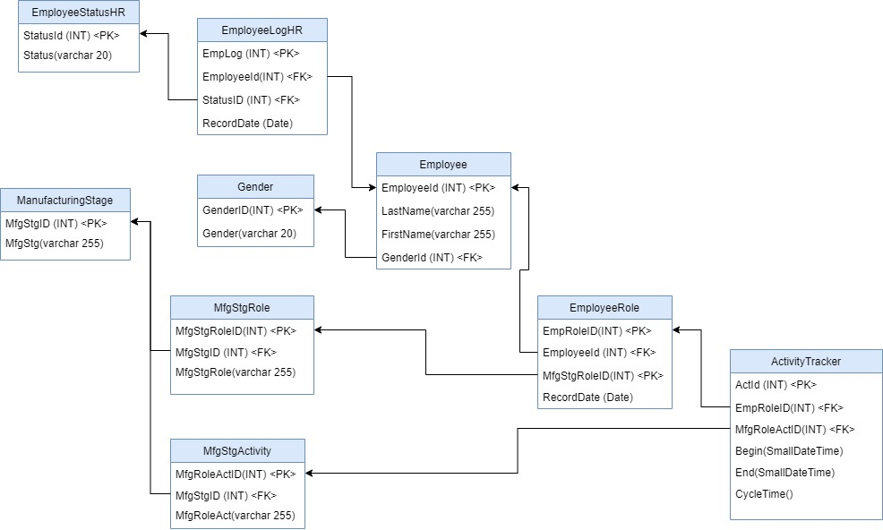

# Entities

Stored Procedures

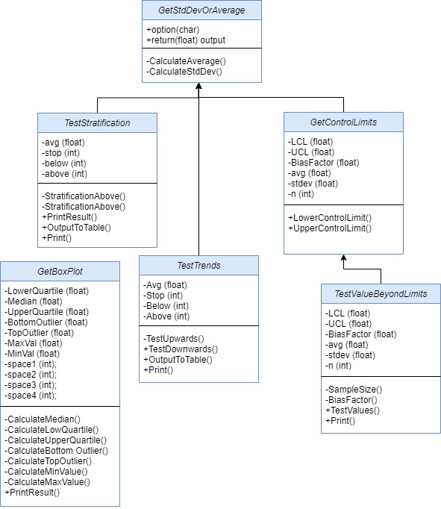

# **Bibliography**

1. **Promodel.** . Promodel Better Decisions - Faster. <https://www.promodel.com>
2. **Standard Time.** .Manufacturing Time Tracking [https://www.stdtime.com/](https://www.stdtime.com/features/timesheet-features.htm)
3. **Control Charts,** also known as Shewhart charts or process-behavior charts, are a statistical process control tool used to determine if a manufacturing or business process is in a state of control. <https://en.wikipedia.org/wiki/Control_chart>